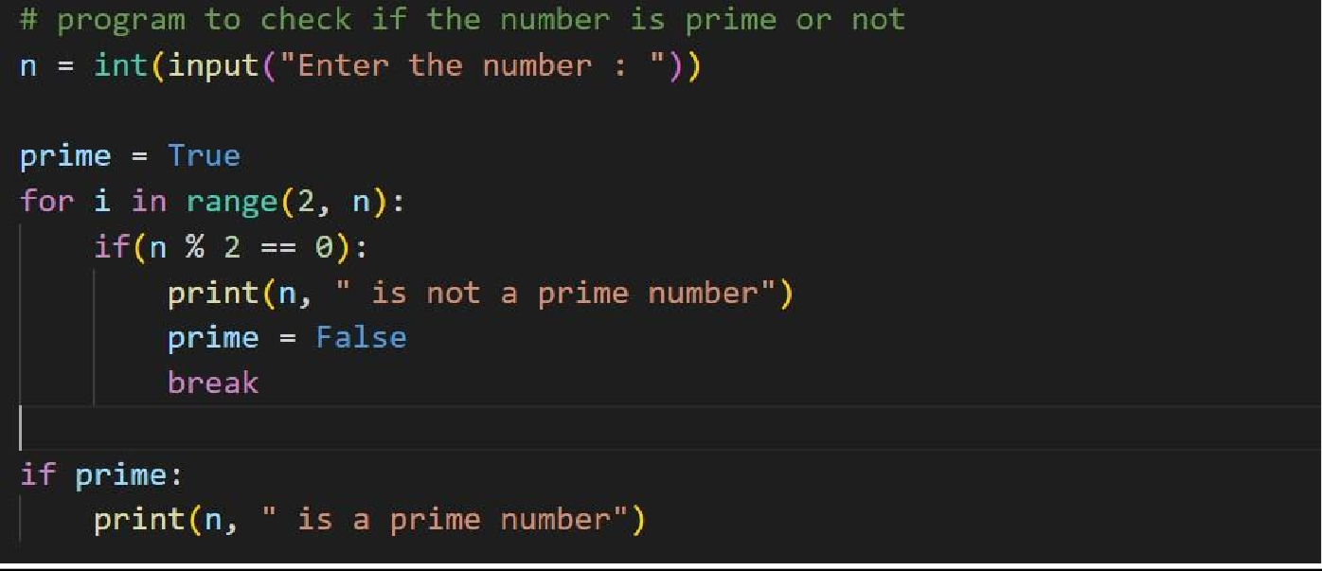Program1:

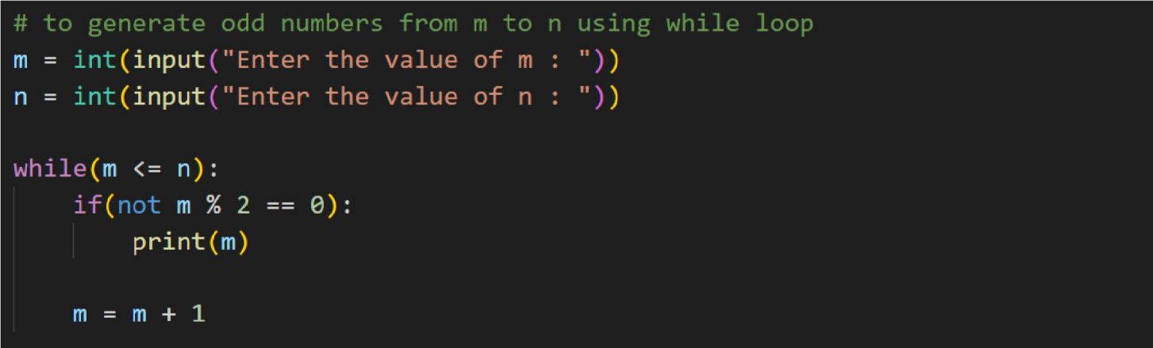Program2:

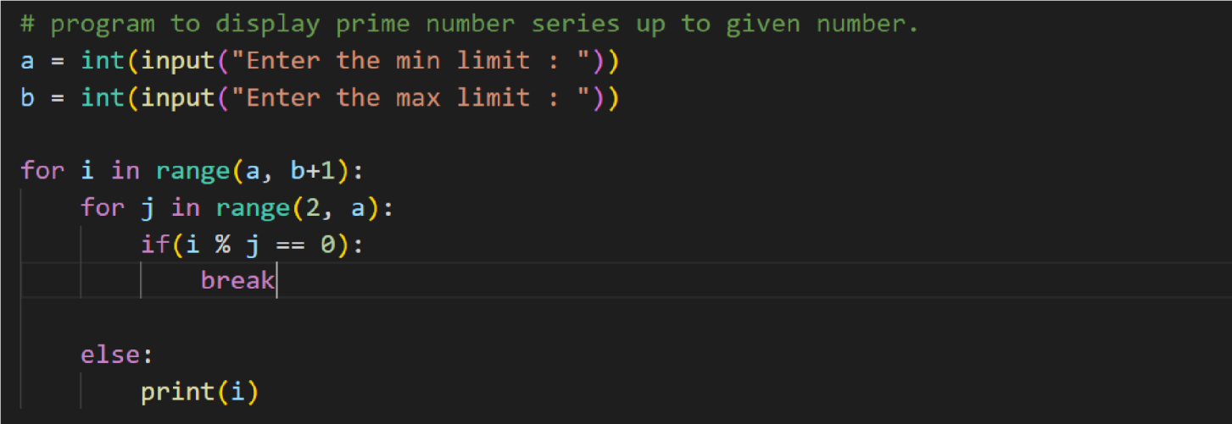Program3:

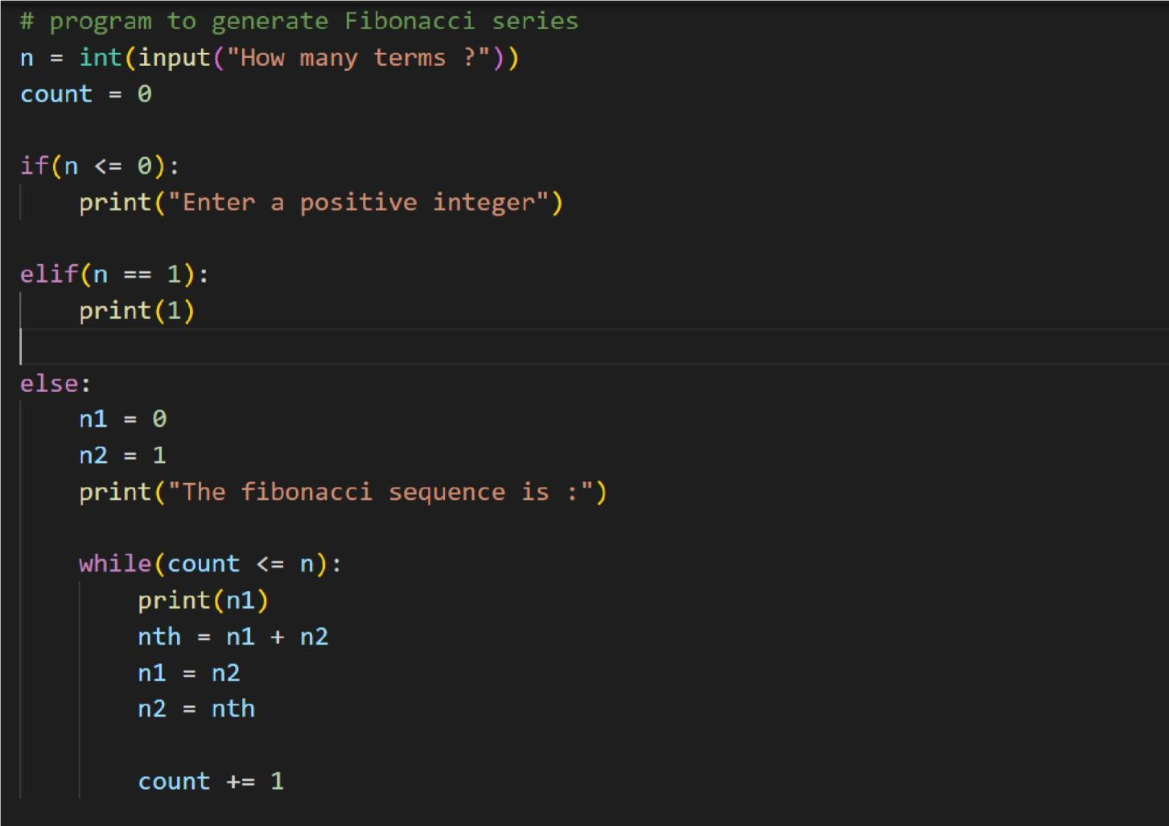Program4:

**Submitted by**

1. Sabari Shree R
2. Varsha K P
3. Sudhan I
4. Krishnakanth G V